(See page 3 for Cont and 1st buttons)

1. Drag the Hands you want into aaBridge

In this example the hands are in a folder called BB_Students which is updated by Google Drive but you can get and use lin files from anywhere.

Click on the SMALL Google Drive icon on your system. MAC's look top right, (on a Mac the Icon has no color) for the Windows icon look bottom right.

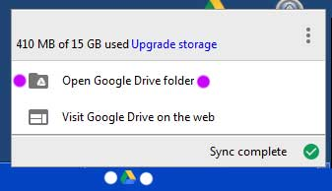
The google drive popup will open.

Click on Open Google Drive folder (purple dots)

The You will now see the BB_Students folder

2. Drag BB_Students
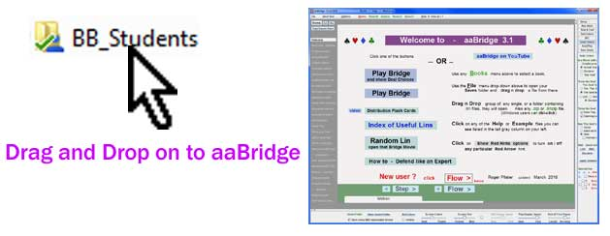
Drag the BB_Students folder on to an open aaBridge window.

All the .lin files will appear (in the left hand column) Click on one.

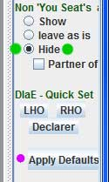
3. Apply Defaults and set 'Hide'

To make sure some of the other seat settings are not set from a previous use.

Click the Apply Defaults button (the pink dot IS visible in aaBridge)!

Select the Hide setting (green dots NOT visible in aaBridge)

Or if the Show (show Opps hands) is more to your needs choose that.

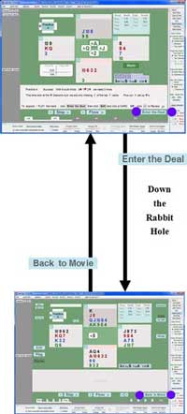
4. Enter the Deal

So your are working through the supplied hands and you want to take over the display of the material and investigate or "play" the hand yourself.

Click Enter the Deal (purple dots in the top box) you will now go "down rabbit hole" into the deal. (Purple dots in the top image.)
(The same button now called "Back to Movie" will take you back)

5. Click Play
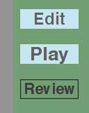
As you will see when you Enter the Deal you always start in Review mode. That is why the Review button looks different.

Click Play

And you are done. Now Click the cards to play them

Why this works (in case you are interested) is because when you pressed Apply Defaults earlier, aaBridge was set to start the Review with the lead already played and showing.

When you click Play aaBridge discards any play already recorded from after the position being shown. The aaBridge bots will then play the Opps hands and do their best.

You can always just stay in Edit mode and play the cards for all hands.

You can also control visibility (Show / Hide button in Green baize area) and or rotate the seat positions "< > " buttons in the upper left.

Hint - If the bots defend badly, you can fix it by ...
Click Edit, Click Undo, Play the correct card, Click Play, and continue.

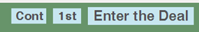
Cont & 1st

Two shortcuts have been added as a convenience.

Cont does an Enter the Deal and then jumps to the end of any play and goes into Play mode. You are then left to continue the play against the aaBridge bots.

1st does an Enter the Deal and then discards all play except for the 1st lead. You are then left to play the whole hand yourself against the aaBridge bots.

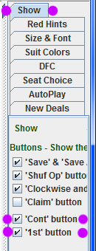

Make the Cont & 1st buttons visible

You will need to make these two buttons visible before you can use them.

On the menubar click

Options > Show and now, in the far right hand column and check the

'Cont' and '1st' checkboxes.

and the hint still applies.

Hint - If the bots defend badly, you can fix it by ...
Click Edit, Click Undo, Play the correct card, Click Play, and continue.

<end of document>

